**THREE.JS Solar System Documentation**

I used Vscode to create my project and I used the live server extension to run the project in chrome.

**Camera Controls:**

Left mouse button: Rotate

Right mouse button: Pan

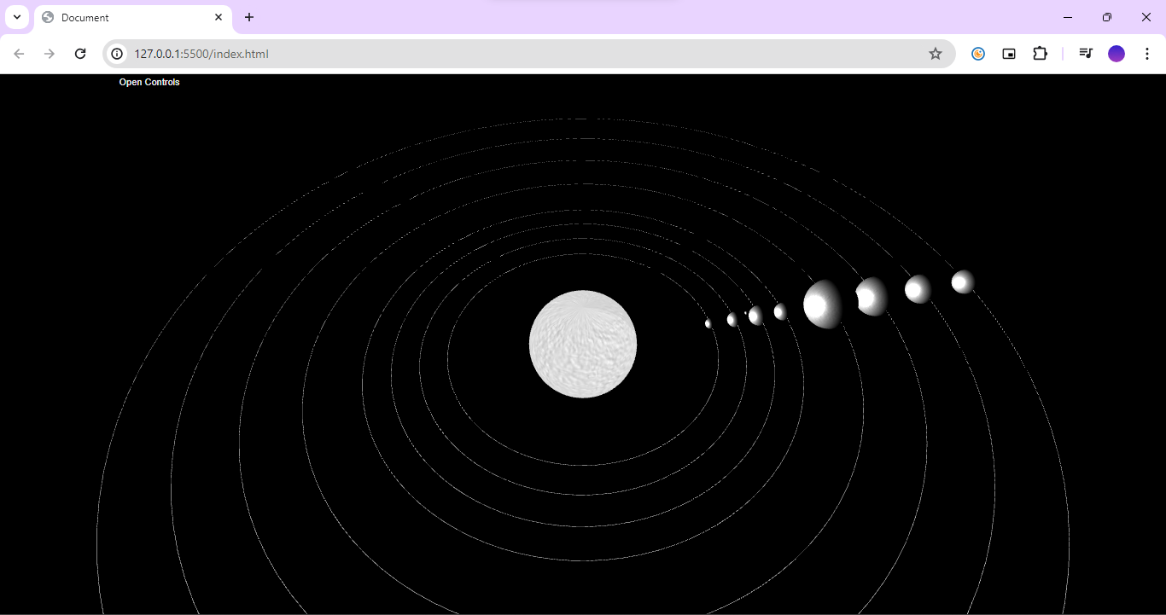Scroll wheel: Zoom in/Zoom out

Open GUI controls



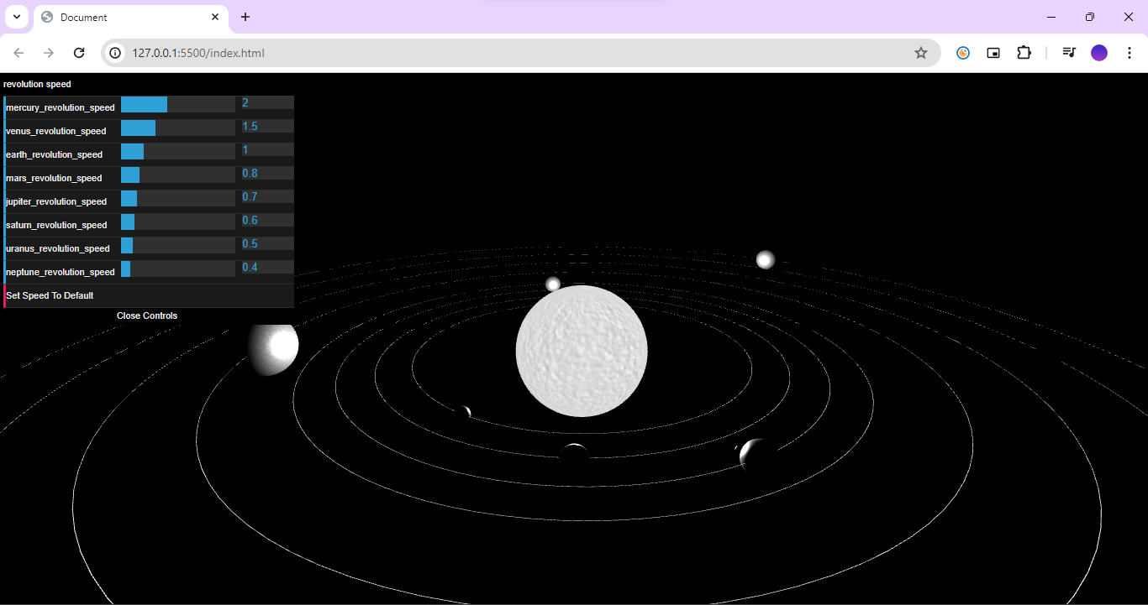

Click to set all the revolution speeds back to default

Adjust the sliders to control the revolution speeds of the planets

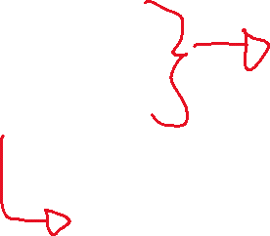

**Software and extension:**

**1)**



-VSCODE

AND

2)

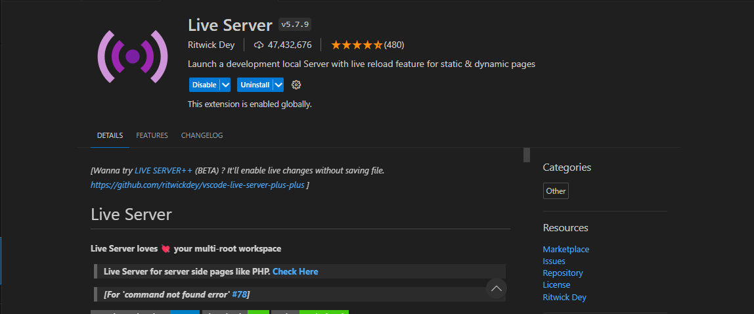

LIVE SERVER EXTENSION

-Search for the live server extension in the extension tab in vscode.

- A restart of vscode is recommended to properly enable the extension.

- I used dat.gui for the gui, to install, I typed the following in the terminal:

npm install --save dat.gui

- Right click on the html file and select ‘open with live server’.



I deployed the solar system project using netlify:

https://enchanting-blini-4ac7e5.netlify.app/